Final Project Synopsis

This project has aimed to deploy an edge-based machine learning model. The primary objective is to be able to take a picture of a dog on an android device and have our model detect which breed the dog may belong to, from a list of different possible breeds.

The dataset that is being used to train our model comes from Stanford and can be found [here](http://vision.stanford.edu/aditya86/ImageNetDogs/). This dataset contains over twenty thousand images, which span across 120 different breeds. This comes out to approximately 170 images per breed, however some breeds contain significantly more or less, reaching from 150 to 240 images for specific breeds. Additionally, some of the breeds are arguably too similar to be truly distinguishable from each other.

To train the model, Google Firebase was utilized. Their AutoML tool within their machine learning software was able to take the data provided and train our model. After an hour of training time, Firebase provided us with metrics for our model, show below.

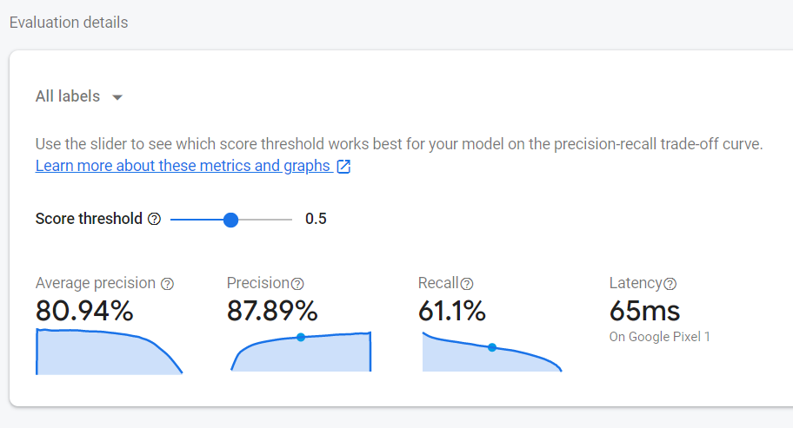

With a halfway score threshold, we can see that the precision our model was fairly accurate while our recall was not as great. Adjusting the score threshold surprisingly did not make our recall much better.

Once the model was trained, we were then able to import it into Android Studio to be used on our android device. As our base code, we utilized the ML kit that is provided by google for edge devices. There is a lot of java code that needed to be modified to accommodate our specific model. Changing the code was easy enough, and we were able to successfully launch our app on our android device.

A screenshot of our android device using the model to detect dog breeds can be seen below.

